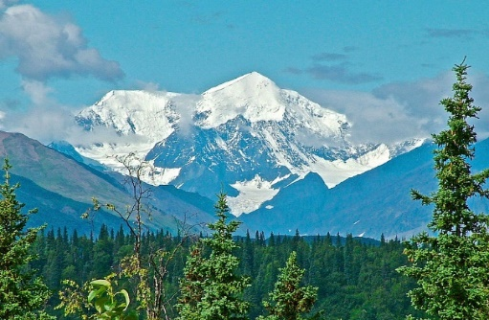
VBC Volunteer and Work Team Alaskan Adventure Excursions (plan a minimum 1-2 full days for each)
Denali State Park is an integral part of one of North America's most spectacularly beautiful regions. The park's 325,240 acres, almost one-half the size of Rhode Island, provide the visitor with a great variety of recreational opportunities, ranging from roadside camping to wilderness exploration.
4-41/2 hrs drive 264 miles from VBC - tourist shops, sightseeing
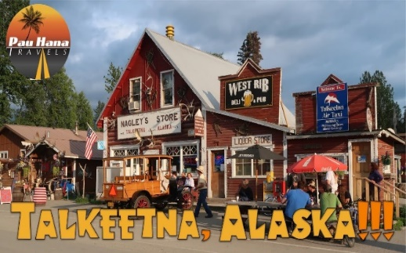
Talkeetna The historic village of Talkeetna is nestled at the base of North America’s tallest peak, Denali. Talkeetna has an outstanding panoramic view of the Alaska Range that can be enjoyed and photographed from several locations as you wander through our town and discover what this unique location has to offer
2hr 30 min drive, 127 miles from VBC - tourist shops, sightseeing
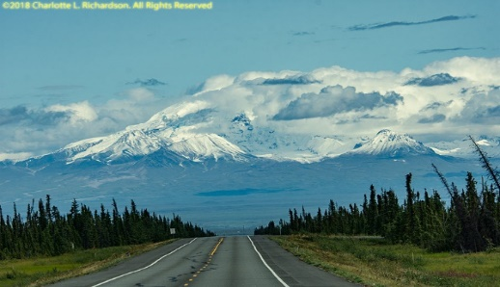
Glenallen and Copper River Valley (breakfast in Eureka) Glennallen provides access to the Wrangell Mountains, a popular destination for backcountry recreation, superb sport fishing, river rafting and Native cultures. Copper Center, which lies a few miles east of Glennallen, is the home of the ranger station for Wrangell-St. Elias National Park and Preserve, the largest national park in the United States.

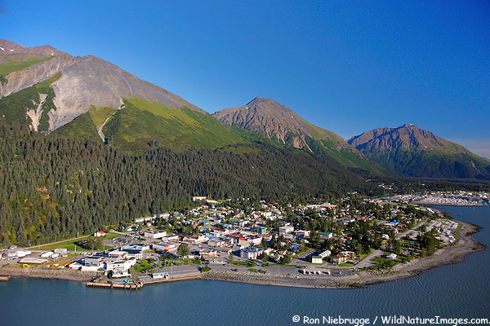
Seward Sandwiched between the Kenai mountains and the waters of Kenai Fjords National Park, Seward is one of Alaska's oldest and most scenic communities, with Mt. Marathon rising steeply behind the town. With a seaside village, which offers a bustling harbor, quaint shops and galleries, and one of Alaska's best wildlife spectacles and some of its most beautiful fjords and glaciers. Humpback and killer whales, sea otters, harbor seals, sea lions, and puffins crowd the park's waters.
4 hr drive, 214 miles from VBC - tourist shops, sightseeing
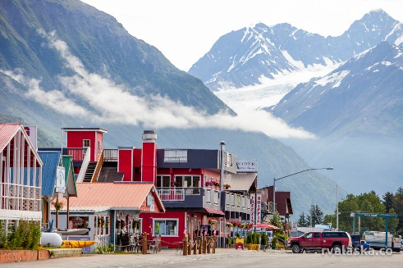
Valdez (Salmon Fishing) (breakfast in Eureka) Located near the head of a deep fjord in Prince William Sound, Valdez is a mix of tidewater glaciers, rainforests, and majestic mountains, wildlife on both land and sea and so much more. Valdez offers unparalleled natural scenery that is matched only by the abundant activities offered throughout the year
3hr 30 min drive, 210 miles from VBC - tourist shops, sightseeing
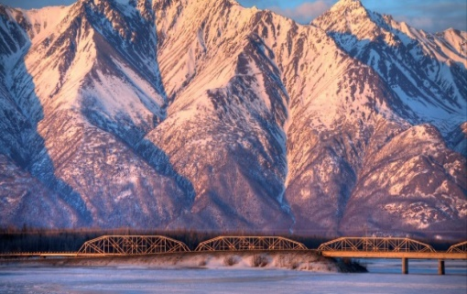
Knik The Knik River Valley is a scenic, secluded valley nestled up against the Chugach Mountains. This hidden gem of the Mat-Su Valley is an adventure seeker's delight, as you'll find everything you dreamed Alaska would be - wilderness, outdoor recreation opportunities, mountains, glaciers, rivers and wildlife. The Knik River Valley is located off the Old Glenn Highway, with Knik River Road providing access to trails, fishing, and spectacular views.
Palmer Alaska, 62 miles from VBC - Sightseeing
Transportation in State: VBC Van(s) may be available for Work Team use with no charge if visiting Alaska attractions within 25 miles. Over 25 miles the Work Team is responsible for fuel and a .25 / mile maintenance fee. Drivers of VBC vans must be over 25 years old and show proof a clean driving record (easily done on-line)

